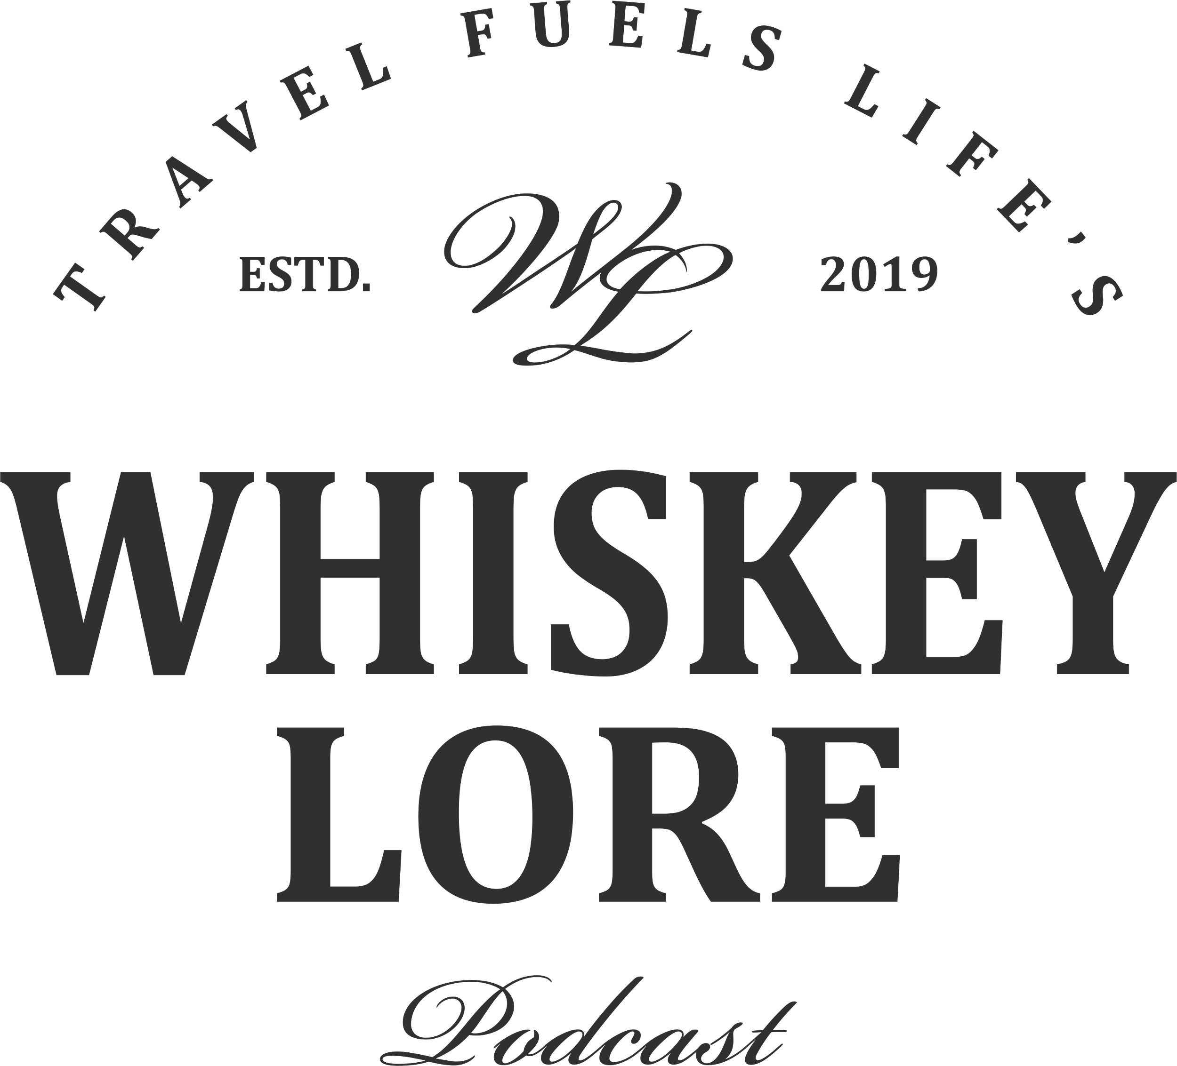

FOR IMMEDIATE RELEASE

**Whiskey Lore’s New Book Reveals the Lost Story of Tennessee Whiskey’s Unique 250-Year Legacy**

**GREENVILLE, SC (January 18, 2024)** Today, Whiskey Lore officially announces the worldwide release of best-selling author Drew Hannush’s epic tale, *The Lost History of Tennessee Whiskey* on audiobook and paperback. After living for more than a century in the shadow of Kentucky Bourbon, this new book shows a completely different side to America’s early distilling legacy. With stories collected from historic books, newspapers, and government archives, Hannush gets past marketing and oral tradition to find the authentic story of a state that was once at the forefront of whiskey production in America.

The book chronicles a distilling tradition that goes back to the very origins of the country. In this 420 page epic, Hannush digs into the state’s pre-Revolutionary War distilling heritage, the barter economy, the state’s agricultural development, the rise of the industry, tavern culture, wholesalers and distillers, the temperance movement, and the impact of the federal excise tax on traditional distilling.

“So much happened before Jack Daniel ever partnered in his first distillery. Yet people still think that is where the story started,” said Hannush. “The Uncle Nearest story opened my eyes to the incomplete story of Tennessee whiskey. I found a whole century hidden from the record.”

There is a certain amount of serendipity in Drew Hannush connecting with the lost stories of Tennessee Whiskey. For the last four years, he has traveled to over 250 distilleries in Scotland, Ireland, and the United States, absorbing the histories inherent in each region. The contradictions in some stories led Hannush to seek the truth in his myth busting podcast Whiskey Lore Stories. Tennessee was a treasure trove of stories and myths.

“One of the great stories I tell is of Nancy Patterson, an enslaved woman who became a well respected distiller and ran her own distillery for nearly thirty years. There were stories of political intrigue and battles between moonshiners and revenuers. And the biggest shocker was the gun battle in the streets of Nashville that killed the Tennessee whiskey industry,” said Hannush. ”These stories were lost for too long.”

Since doing his research for this book, Hannush says bottles that say Tennessee Bourbon seem strange to him now. “I think a lot of Tennesseans will be surprised at how strongly their ancestors opposed their spirits being compared to Bourbon. They were strict traditionalists. To them, Kentucky distillers took shortcuts for the sake of industrialization. There was a pride in the legacy of Tennessee Whiskey. I hope these stories reignite that passion for Tennessee’s heritage.”

The Lost History of Tennessee Whiskey is published by Travel Fuels Life, LLC and available as an audiobook from Apple Books and Spotify. The paperback is available at all major online retailers.

**About Whiskey Lore**

Travel Fuels Life, LLC (dba Whiskey Lore) is a production and education company established in 2019. Its focus is on whiskey education and whiskey travel through the creation of books, podcasts, and events.

**Contact Information**

To reach Drew Hannush for interview opportunities and for review copies of the book, email [media@whiskey-lore.com](mailto:media@whiskey-lore.com) or phone +1 864-918-5812 or visit [whiskey-lore.com/mediakit](https://www.whiskey-lore.com/about/media-kit-and-resources)

###